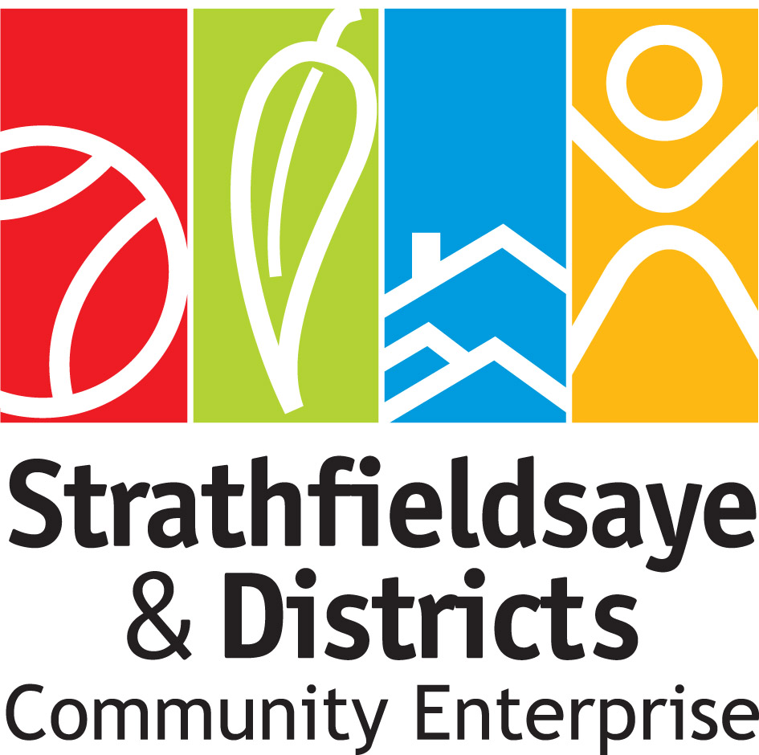

Strathfieldsaye and Districts Community Enterprise
Annual General Meeting - Agenda
Date: | Monday 1st November 2021
Time: | 7pm
Place: | Virtual Meeting - via Zoom (RSVP for link and password)

Item | Description | Responsible
1 | Welcome and introductions | Chairperson
2 | Apologies | Secretary
3 | Review of actions from previous annual general meeting | Chairperson
4 | Acceptance of minutes of previous annual general meeting | Chairperson
5 | Chairperson’s report | Chairperson
6 | Treasurer’s report | Treasurer
7 | Questions to directors | Chairperson
8 | Acceptance of financial statements | Treasurer
9 | Acceptance of annual report | Chairperson
10 | Election of directors | Returning Officer
11 | Guest Presentations | Bendigo Bank  Bendigo Telco
12 | Meeting close | Chairperson

