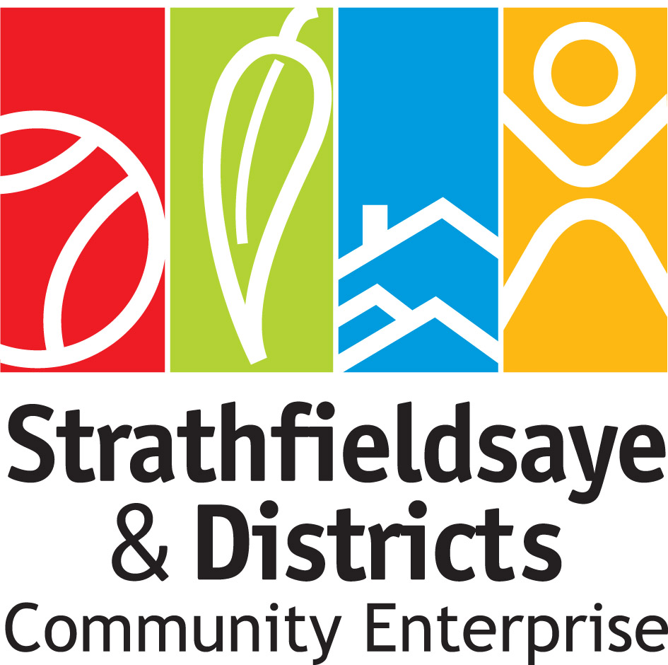
4 October 2021

Notice of the annual general meeting of
Strathfieldsaye and Districts Community Enterprise
Dear member,
This is to advise you of the upcoming annual general meeting of the members of Strathfieldsaye and Districts Community Enterprise. The details of this meeting are as follows:
Date: | Monday 1st November 2021
Time: | 7pm
Place: | Virtual Meeting via Zoom.
Attached are:
- the agenda for this meeting
- the minutes of the last annual general meeting.
At the meeting, members will have the opportunity to:
- find out about SDCE’s activities and finances
- ask questions about the operations and finances of SDCE
- speak about any items on the agenda
At the meeting, members will be asked to:
- accept the minutes of the last annual general meeting
- accept the annual report
- accept the annual financial statement
- appoint directors
Please RSVP to sdce@strathfieldsaye.com.au

Regards,
Dennis Johanson
Chair

